Software testing? Activity to check where the actual result matches the expected result and the system is defect-free

Principle of testing:

1. Detection of bugs
2. Effective testing
3. Early testing
4. Dectec in clustering
5. Error-free software is a myth

Verification and validation work together

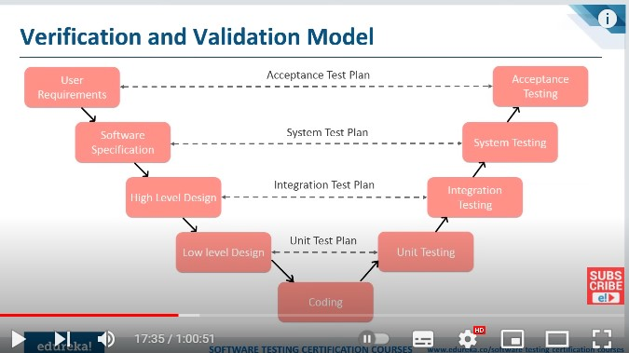

Software testing life cycle:(RTTETT)

1. Requirement analysis
2. Test planning
3. Test case development
4. Environment setup
5. Test execution
6. Test cycle closer

Two types of testing

Manual

Automation → scripts written by tester

Black box testing → It also called behavior testing means every result is unknown to the tester. Internal logic is not known to the tester

White box testing: Internal logic and behavior is known to the tester

Gray box testing: partial know to tester

Functional and no functional testing

Functional testing: unit testing, acceptance testing, smoke testing

Nonfunctional testing: performance testing, load testing, volume, salability testing

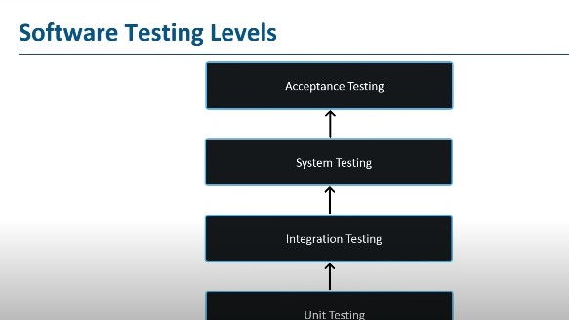

Selenium: interacts with web elements using locators and locators are nothing but HTML tags

Requirements are three types:

1. business requirements

2. Architechtarul requirements

3. System and integration requirements

Test planning is the most important thing in STLC

We choose different types of testing (unit testing, API, Integration, install/uninstall agile..,system testing)

Unit testing: it tests small pieces of software of the application

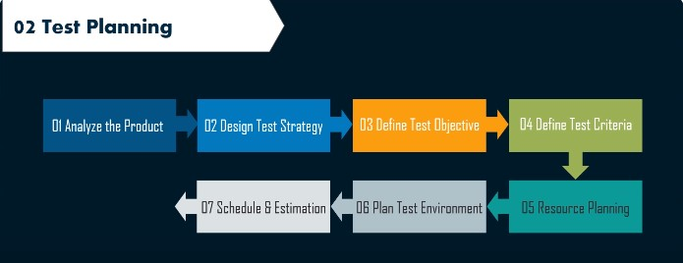

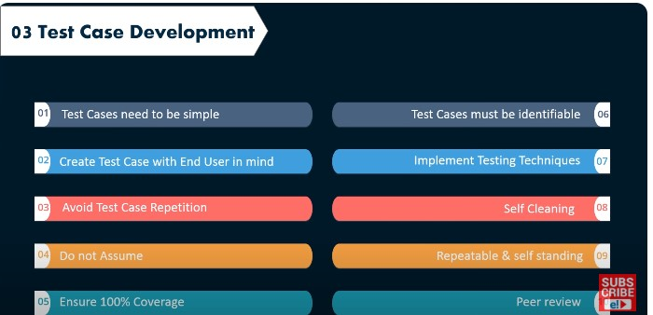

4. Environment setup: not only check in local but also check in a server environment and frontend works perfectly analyze what software and hardware needed

5. test execution: after preparing the test scripts when when test execution start it is import to mark down which test case (pass, fail or blocked or not run) and make a report

6. Test cycle closer: finalize and archive and document system acceptance